SMART DUSTBIN
Abstract:
In the present day scenario,many times we see that the garbage bins or dust placed at public places in the cities are overflowing due to increase in the waste everyday.
It creates unhygienic condition for the people and creates bad smell around the surroundings this leads in spreading some deadly diseases and human illness, to avoid such a situation we are planning to design “ IoT based management for the smart cities.”
Objective:
IOT based waste management system for the smart city.

Working Mechanism:
The project module is divided into two parts. Transmitter section and reciever section.
In this sensors are used to detect the level in the dustbin whether the dustbin is full or empty.
The sensors senses the content of the dustbin and sends the signals or the data to the Intel galileo Gen2 kit.

Block Diagram:

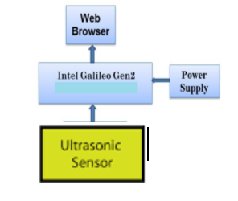

CircuitDiagram:

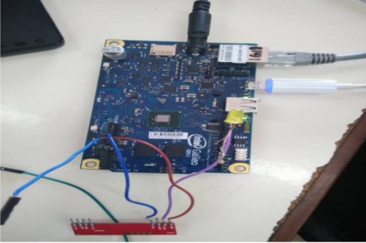
Advantages:
Real time information on the fill level of the dustbin.
Cost reduction and resourse optimization.
Improves environment quality.
Intelligent management of the services in the city.
Effective usage of dustbins.
Challenges faced with the project:
The data received by the sensors is difficult to send to Intel galileo gen2 kit through wirelessly.
Applications:
It is used like a level indicator so,we can use this for various applicatoins.
1.Water level indicator
2.Fuel indicators in some factories
Conclusion:
By implementing this proposed system the cost reduction, resourse optimization, effective usageof smart dustbins can be done.
This system indirectly reducing traffic in the city.
Our system will inform the status of each and every dustbin in real time so that the concerned authority can send the garbage collection vehicle only when the dustbin is full.
Cost of the Project:
5000/-

